**R Code for Examples in the book**

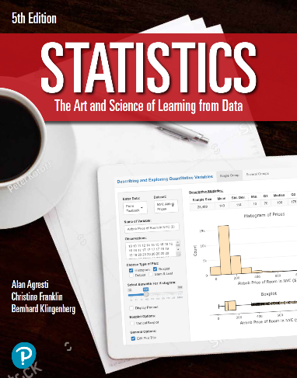

***“Statistics: The Art and Science of Learning from Data”***

**by Agresti, Franklin and Klingenberg, 5th edition**

**Chapter 2**

**Example 5: Health Value of Cereals – Stem-and-Leaf Plots**

## Read in Sodium values:

sodium <- c(0, 340, 70, 140, 200, 180, 210, 150, 100, 130, 140, 180, 190, 160,290, 50, 220, 180, 200, 210)

## Basic Stem & Leaf Plot:

stem(sodium)

##   
## The decimal point is 2 digit(s) to the right of the |  
##   
## 0 | 057  
## 1 | 0344568889  
## 2 | 001129  
## 3 | 4

## 

## More appropriate (the one from the book):

stem(sodium, scale=10)

##   
## The decimal point is 1 digit(s) to the right of the |  
##   
## 0 | 0  
## 1 |   
## 2 |   
## 3 |   
## 4 |   
## 5 | 0  
## 6 |   
## 7 | 0  
## 8 |   
## 9 |   
## 10 | 0  
## 11 |   
## 12 |   
## 13 | 0  
## 14 | 00  
## 15 | 0  
## 16 | 0  
## 17 |   
## 18 | 000  
## 19 | 0  
## 20 | 00  
## 21 | 00  
## 22 | 0  
## 23 |   
## 24 |   
## 25 |   
## 26 |   
## 27 |   
## 28 |   
## 29 | 0  
## 30 |   
## 31 |   
## 32 |   
## 33 |   
## 34 | 0